Data insights for holiday destinations

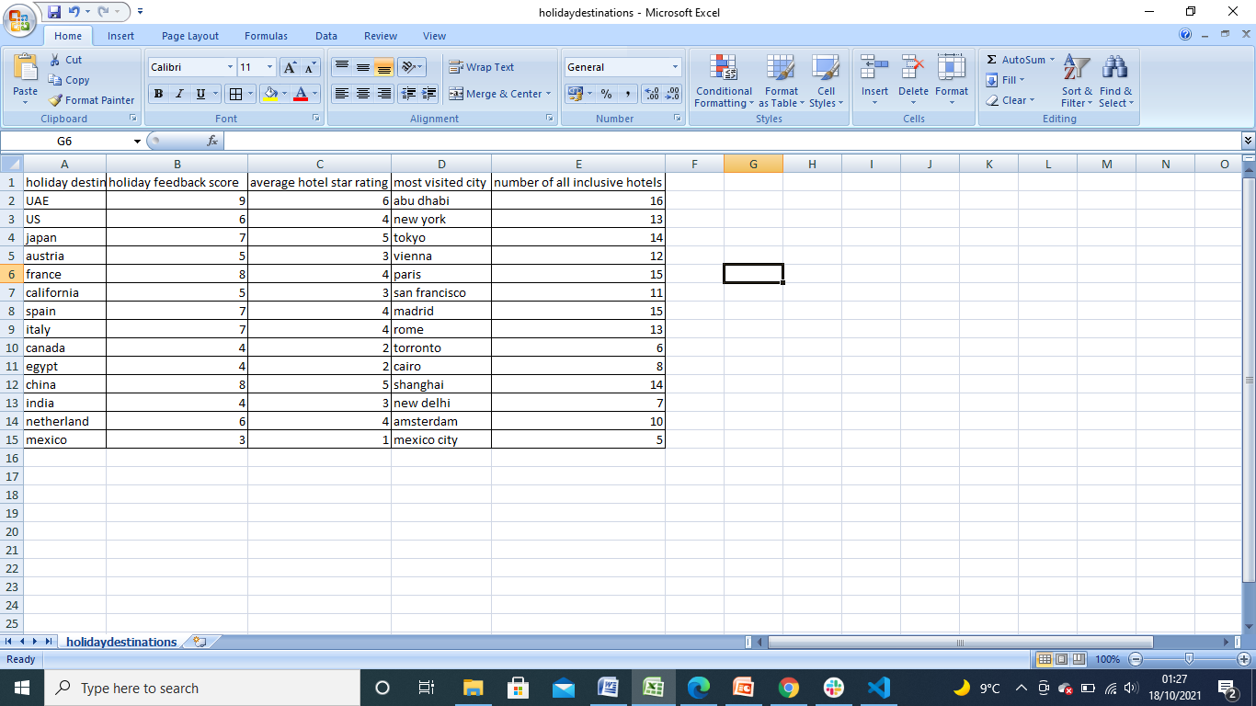

* mean number of all inclusive hotels above all destinations is 11
* the holiday destination with the lowest score is mexico
* the holiday destination with the highest score is UAE
* all holiday destinations have more than 9 all inclusive hotels expect mexico ,india, Egypt and Canada

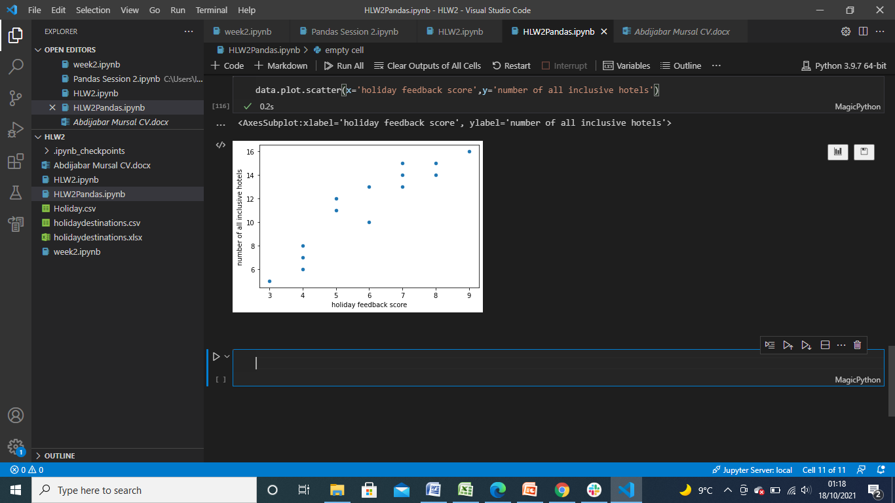

From this scatter graph we can see that there is a positive correlation between the number of all inclusive hotels and holiday feedback score.

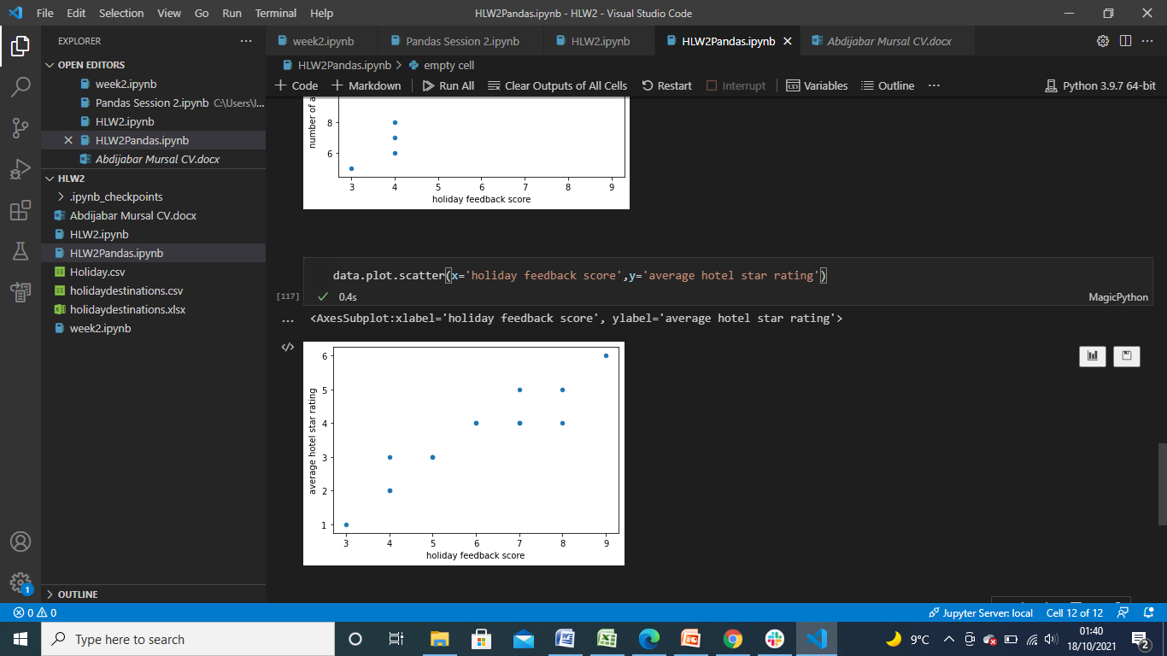

Again there is a positive correlation between average hotel star rating and holiday feedback scores

From this data we can gather that the quality and availability of hotels has a positive impact on the feedback score of travellers in that destination.